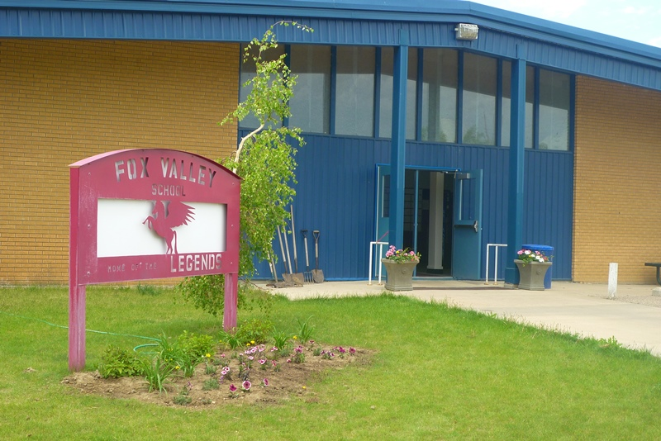
Fox Valley School Newsletter
February 1st, 2020

Richmound Lions
FREE Lunch
for Students & Staff
Wednesday, February 5th
Menu:
Chicken Noodle Soup
Potato Soup
Ham & Cheese Sandwiches
Egg Salad Sandwiches
Juice Box
Rice Krispy or Puffed Wheat

Fox Valley Students & Staff Thank the Richmound Lions Club!!!

A Interesting Way to Think About Vaping and Children…. https://youtu.be/d3aPiGnSe2I

After School Curling News

January 30th was the final round robin games. We will be holding the playoffs on February 6th after school. We had a number of new curlers out this year and they have all been doing very well. - Mrs. Hoffart

Kindergarten to Grade 12 Report Cards went out today!! You should have received an email from production@myschoolsask.com ,letting you know that your child’s report card is available on the parent portal. Within that email, I’ve included a link to the parent portal as well as some instructions for viewing on your phone. You may also be asked to reset your password. I was able to reset on my phone but this isn’t the case for everyone (thinking it has to do with the type of phone you have….maybe). If you have not yet logged onto MSS please do so now!! This is how you get your child’s report cards!!! If you have a sasktel.net email address, please check your spam folder for this email.
If you have any problems, please call the school!!!

What’s Happening in the Classrooms?

Goodies for Grands - On Feb. 14th the K/1 Class has invited all Grandparents to school. They will have a celebration honoring their grandparents or a family figure that always supports them. We will begin our celebration by sharing a National Grandparents Song. Then each of the children will read a Narrative Writing they created about their grandparent(s). The grade 10 PAA Class will supply our goodies and serve them to all of us. We will end our celebration with an acrostic poem that's titled, Grandparents. We are all working hard to get ready for our special Day! – Mrs. Hudec

In the 2-3 class we will be busy learning about a variety of countries in social studies. In our science class we will be having 2 presenters come in to help us learn about soils and at the end of the soils unit we will each be building our own worm farm and naming each worm. – Mrs. Sunde

The Grade 4/5 class enjoyed writing Christmas stories before the holidays and we shared them with the K/1 class after Christmas. We enjoyed reading the story "Very Rich" and have just begun "Sweep". Both of these books were Willow Award nominees this year. In math we are working to improve our multiplication and division skills. - Mrs. Hoffart

The grade 4/5 class is in the middle of our Sound unit in Science and are having fun learning through fun experiments! The grade 4/5 class is excited to have a couple Elders come and discuss the importance of relationship to the land for First Nations people in our Social Studies class at the end of the month. PAA 7/8 has been knitting scarves and will continue our Life Skills unit throughout January. The grade 6/7 Physical Education class has been skating and will be curling throughout the month. - Miss Peers

Arts Ed 8/9 Students Wrap Up FNIM Art Unit - For the past two months, the 8/9's have been learning about FNIM art and the significance of nature in their artwork. The students have learned about the importance of the circle in First Nations culture as well as the four directions (N, E, S, W) and about the meaning of animals. The class has been visited by Elouise Mosquito and Lisa Kunz, making dream catchers and learning the circle dance. They have chosen animals that represent their personalities and painted their images on wood. We even tried some wood witling, beading and mask making this term. The students did some great work and learned a lot about the FNIM culture! – Mrs. Wilde

Hi everyone! January was a busy month! Here is a quick recap of the classes I teach (and I've included some questions you can ask your child about what we are learning!):

Math 6 - we are learning about angles! The grade 6s are discovering how to use their protractors to measure, draw, and label angles.
How do you use a protractor to measure angles?
Math 7 - we have just finished our unit on finding the area of circles, parallelograms, and triangles. Next up - more fractions!
How are triangles related to parallelograms?
Math 8 - the grade 8s are working through their rates, ratios, and percents unit. We are discovering different ways to solve problems involving taxes and discounts!
How would you find out the sale price of a $40 sweater that has a discount of 15%?
Math 9 - The grade 9s have been working hard through their course. We just finished our unit on polynomials and now are learning about linear functions!
If I make 2 cookies for each person attending the party plus 5 extra just in case, how can I find out how many people are attending the party if I make a total of 100 cookies?
PAA 8/9 - We are still working through our Photography unit! What is the Rule-Of-Thirds?
Science 10 - The grade 10s wrote their final exam on Wednesday, January 29th for this course. Great job everyone!
Health 8/9 - Our last Health class was on Monday, January 27th. We learned about different types of families, stereotypes, substance use, relationships, and goal setting.

Miss Connor

Grade 8 students please return you Immunization Permission Form to the school ASAP!!!

SRC February Spirit Days

February 5 – Hat Day
February 12 – Formal Day
February 26 – Pink Day – Wear PINK to show your support against Bullying!!!

February at a Glance
January 31st/February 1st – Sr. SWAC Curling Sectionals @ Hazlet
February 5th – Literacy Afternoon at FVS. Sponsored by the SCC. All parents are invited to participate! 1:30 p.m. – 3 p.m. Book Swap books can be given to Mrs. Bosch in the Library!!
February 5th – Richmound Lions FREE Lunch for Students & Staff
February 5th – Hat Day
February 6th – Last Day of After School Curling
February 7th – SCC Noon Lunch – Pizza Buns with a juice box. 1 for $4 or 2 for $5
February 7th/8th –Jr. Sectional Curling @ Maple Creek
Sr. SWAC Curling Districts @ Leader
February 10th – SCC Meeting at 6 p.m.
February 10th – 14th – Staff Appreciation Week
February 12th – Formal Day
February 13th – Grade 4 -12 SKI TRIP
February 14th – Happy Valentine’s Day!!
February 14th – Noon Lunch – Mac & Cheese & juice box. Small $4; Large $6. Proceeds go to the Library.
February 17th – 21st - NO SCHOOL!!!!!
February 26th – Pink Day – Wear Pink to show your support against Bullying!!
February 28th – Subway
February 28th – Jr. District Curling @ Eastend/Consul

